Data Management and Visualization

**Assignment – Week 2**

**Running Your First Program**

**By mapolarbear@gmail.com**

First, I would like to remind that for my research I decided to use GAPMINDER data set, containing some indicators, but not all needed to complete my research. To build extended version with more data, I downloaded and uploaded into SAS Studio additional CSV data file and added needed variables to GAPMINDER. Data from following CSV files/datasets added for the purpose of my research using PROC SQL in Part-2 of program, don’t be scared.

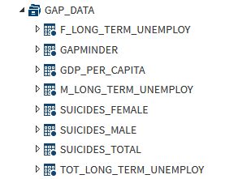

Here is brief description of code:

Part-1 - Retrieve GAPMINDER form provided MYDATA course data

Part-2 - Join/Add needed variables/data from downloaded [www.gapminder.org](http://www.gapminder.org) site

Part-3 - Creation of final GAPMINDER_RSCH dataset with needed labels in corresponding formats

Part-4 - Execution of PROC FEQ to display frequencies for couple variables, including missing values.

Program code can also be found in TXT format at following link:

<https://github.com/mapolarbear/Data-Analysis-Interpretation-Wesleyan-SAS/blob/master/gapbuildDS.txt>

For verification purposes there are originally 213 countries in GAPMINDER dataset and if you add Cumulative Frequency to Missing Freq., you will get same 213, means nothing is skipped or removed.

In addition, based on my preliminary analysis of data I noticed that data is missing some countries, which means that my samples will be smaller than expected. I also noticed that some countries has higher **suicideper100TH** rating, it will be interesting to see if **suicideper100TH** correlates with **employrate** and **long term unemployment** ratings for each category.

1. **Output of program**

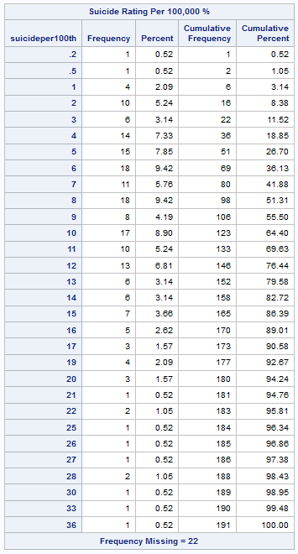

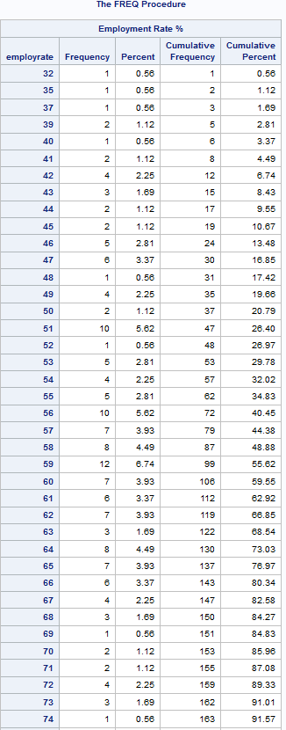

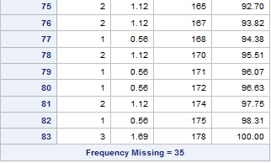

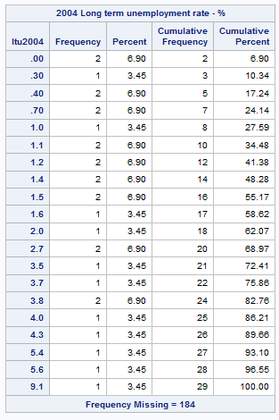

1. **Program code**

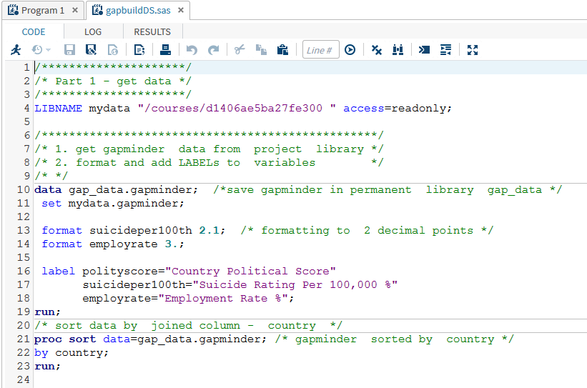

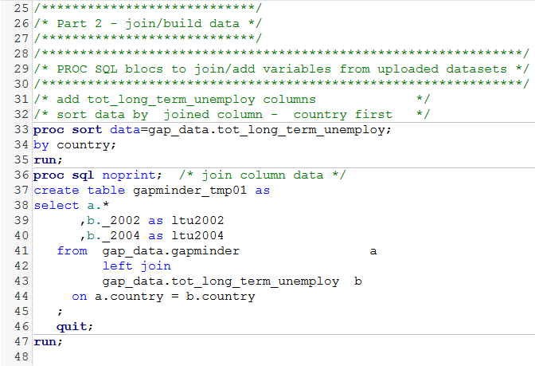

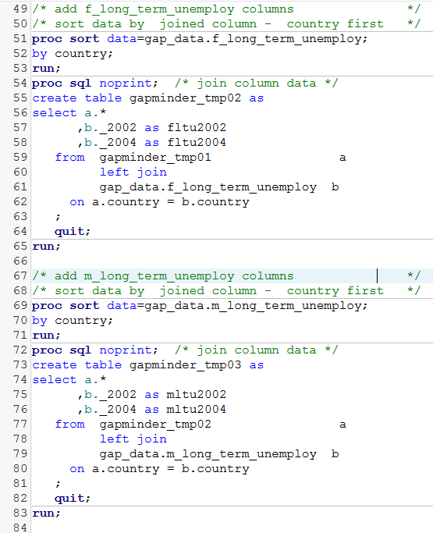

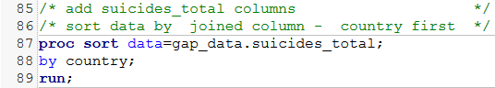

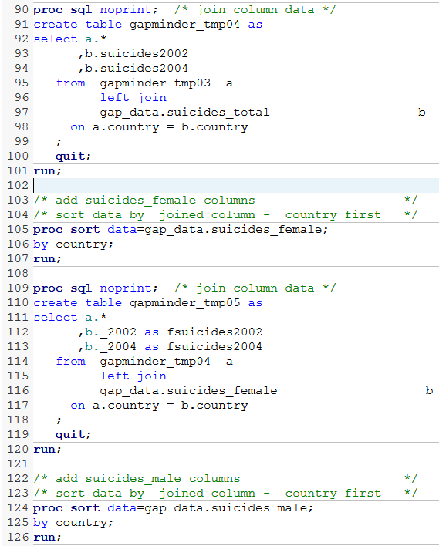

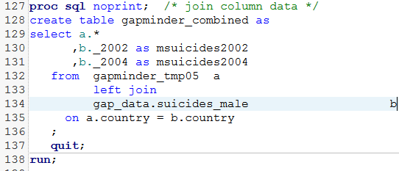

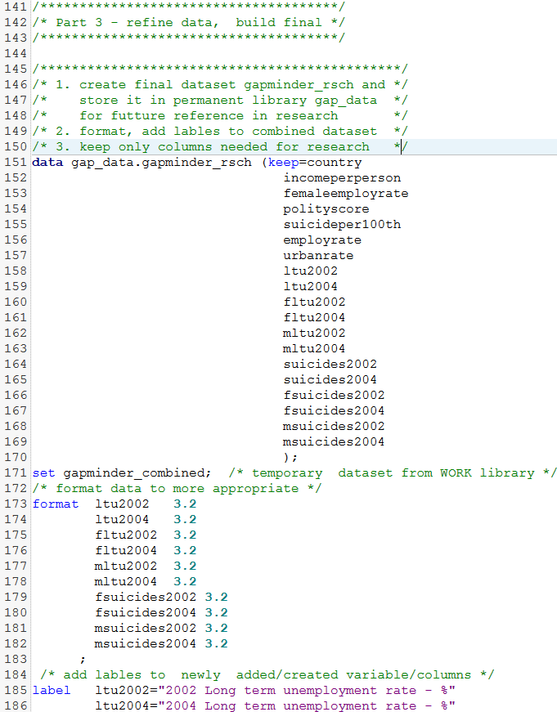



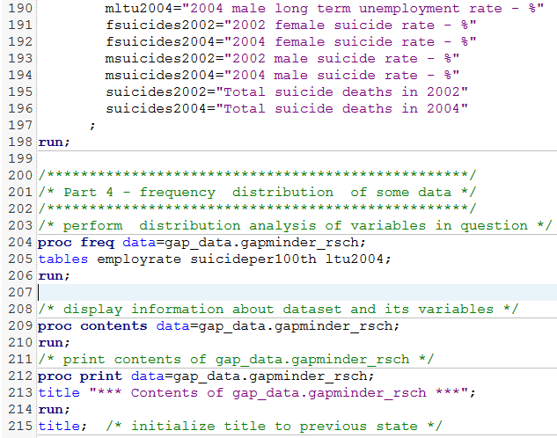

Document can be found also at following link at [www.github.com](http://www.github.com):

<https://github.com/mapolarbear/Data-Analysis-Interpretation-Wesleyan-SAS/blob/master/Assignment%20-Week-2.docx>